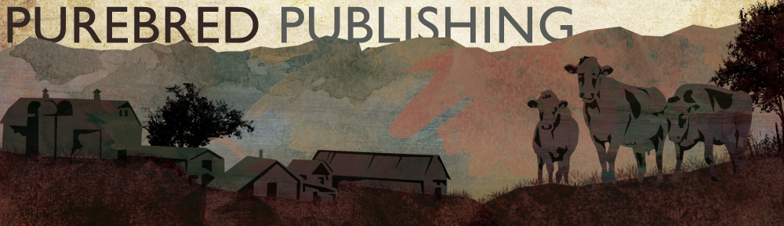
Spec Sheet
Guernsey Breeders’ Journal | Brown Swiss Bulletin | Ayrshire Digest | Milking Shorthorn Journal

Sizing
Full page:
Live space: 46 picas wide X 59 picas deep (7.45 inches x 9.875 inches)
Trim size: 50.5 picas wide X 65 picas deep (8.375 inches x 10.875 inches)
Full bleed: add ¼ inch on all sides

Center Spread:
Live space: 94 picas wide X 59 picas deep (15.57 inches x 9.875 inches)
Trim size: 100.5 picas wide X 65 picas deep (16.75 inches x 10.875 inches deep)
Full bleed: add ¼ inch on all sides

Two-Thirds Page:
Horizontal: 44.26 picas wide X 39.6 picas deep

Half Page:
Horizontal: 44.26 picas wide X 29.26 picas deep (7.377 inches x 4.875 inches)
Vertical: 21 picas wide X 59 picas deep (3.5 inches x 9.875 inches) ONLY IF REQUESTED

One-Third Page:
Horizontal: 44.26 picas wide X 19.8 picas deep

Quarter Page:
21 picas wide X 29 picas deep (3.5 inches x 4.875 inches)

Pricing
Back Cover $618 Center Spread $979
Inside Covers $540 Full Page $515
2/3 Page $412 1/2 Page $355
1/3 Page $250 1/4 Page $207
Business Card $75 (AY)
Column Inch $45 (GU, BS, MS)
State Block $60 (billed through the state)

Additional fees may apply for ordering photos from the photographer and cutout photos.
Contract discounts rates are available.

Specifications for ads submitted Camera Ready:
300 DPI | CMPK | PDF | Full Color

$50 Reformatting ad for other publications
$100 Specialty ad
$285 33.5”x 80” banner with stand
Plus shipping
$200 33.5”x 80” banner with grommets
Plus shipping
$20 16”x 20” poster with grommets
Plus shipping
$40 24”x 36” poster with grommets
Plus shipping
$1.00/ two sided flyer, for 500 flyers
Includes printing and shipping
5% Discount for ad copy received by deadline
10% Camera Ready discount
$50/month Website advertising usguernsey.com

Contact us for online marketing opportunities, brand development, and any other marketing needs!

